Northwest CTC, Ohio

by Charley Flaig

Cincinnati’s Northwest Community Technology Center is located in the Northwest Family Resource Center, an old elementary school building retained by Northwest Local Schools after district school consolidation. The center contains the Northwest Branch of the Portsmouth Public Library, Community Action Head Start Union Center, two South Central Ohio Educational Service Center’s Educational Disadvantaged units, a Pre School Special Needs class, Scioto County Even Start, and the Scioto County ABLE/GED Program. The gymnasium is used daily for youth sports leagues, wedding receptions, fund raisers, reunions, and community meetings.
The Director of Scioto County ABLE and the Coordinator of the Scioto County Even Start co-manage the center. Scioto County ABLE is the manager of the Community Technology Center.
The CTC is on the third year of a three year grant from Verizon through the OCCN. During the two plus years the center has become the focal point of community activities. While the children are at Biddy Basketball practice, parents utilize the CTC for a variety of purposes but mostly to access the internet. The CTC also works in conjunction with the library and Even Start on Family Fun Night activities. The library conducts classes for adults; Even Start provides activities for the birth to five year olds while the CTC hosts the 6 to 15 year olds on various computer related educational activities.
We are also the only avenue for some residents of the community to access the Northwest Local Schools Home Work On-Line program. In the summer, the CTC offers computer assisted remediation and proficiency test refresher classes for the community.
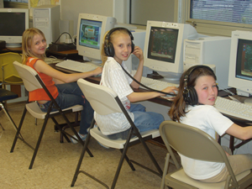
Kids at the Northwest CTC

Another important function of the CTC is job search activities through the Scioto County Work Force Development initiative and the One Stop. Residents submit and update resumes, search for jobs locally and statewide through the State of Ohio’s SCOTI on-line system. This service alone saves some residents over a thirty mile trip into Portsmouth.
The CTC is the only location in Scioto, western Adams and south western Pike Counties where the residents can make copies, use the fax machine, and access the world of the internet at no cost to the resident.
All the above is possible through the cooperation and shared resources of the Northwest Family Resource Centers partners. Scioto County ABLE and Even Start cost share the man hour requirements of the CTC. Special programs and activities costs are interwoven into the over all partner’s contributions.
The ABLE/GED program benefits from the CTC’s computer lab and purchases equipment and supplies that are used by both. Utilities and upkeep are in-kind contributions from the Northwest Local School District.
______________________________________________________________________________

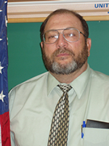
Charley Flaig is the Adult Basic and Literacy Education (ABLE) Director of the Scioto County ABLE Program. He manages twelve sites throughout Scioto County, six of which partner with Even Start Family Literacy Programs. He is a retired Air Force Non Commissioned Officer with 18 years in the Adult Basic Education business. He holds a masters degree from Central Michigan University.

